Compilers can have a profound impact on the performance of an application. Assume that for a program, complier A results in a dynamic instruction count of 1.0E9 and has an execution time of 1.1s, while complier B results in a dynamic instruction count of 1.2E9 and an execution time of 1.5s.

1. Find the average CPI for each program given that the processor has a clock cycle time of 1 ns

‘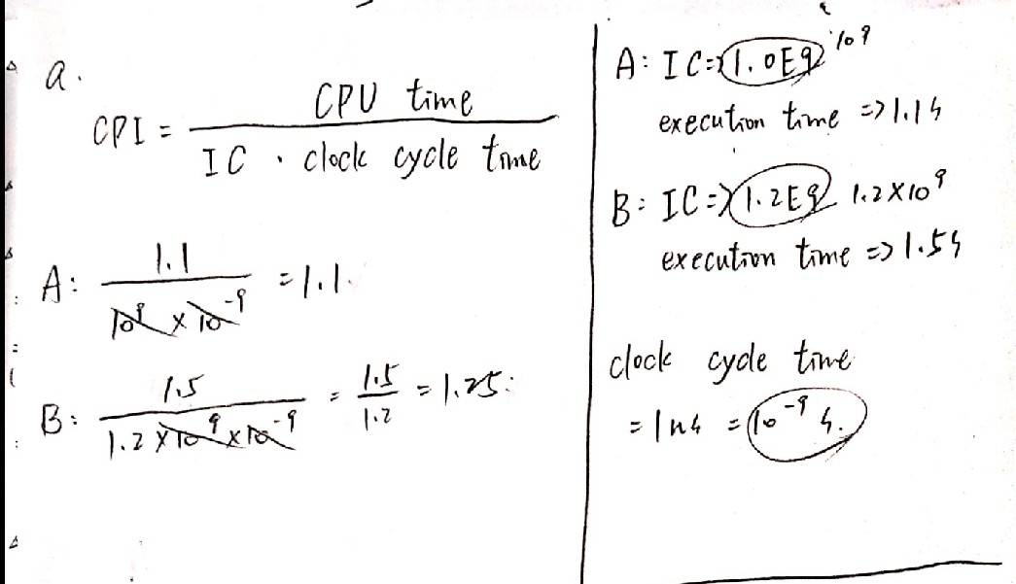

**Ans：CPIA=1.1，CPIB=1.25**

1. Assume the compiled programs run on to different processors. If the execution times on the two processor running compiler A’s code versus the clock of the processor running compiler B’s code.

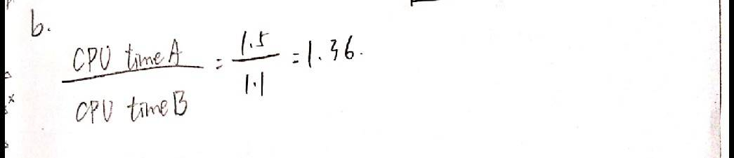

**Ans：B比A快了1.36倍**

1. A new compiler is developed that uses only 6.0E8 instructions and has an average CPI of 1.1. What is the speed up of using this new compiler versus using compiler A or B on the original processor?

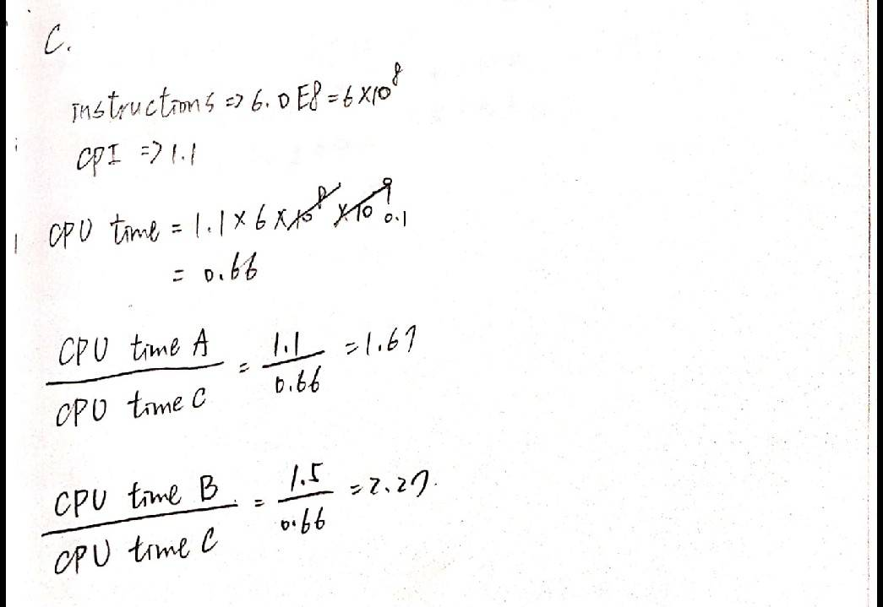

**Ans：C比A快了1.67倍，C比B快了2.27倍**